**Auto scaling Tasks**

1. **Create one VPC in N. Virginia region.**

* Go to aws console
* Go to Vpc and create one vpc in north virginia

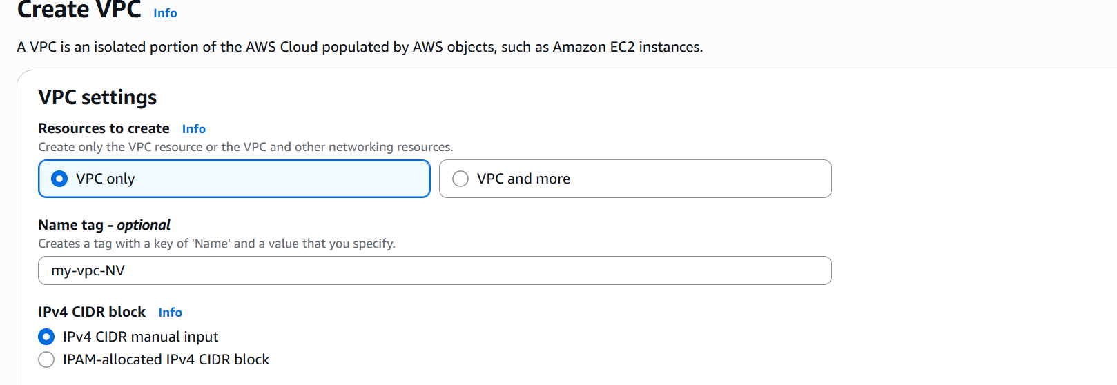

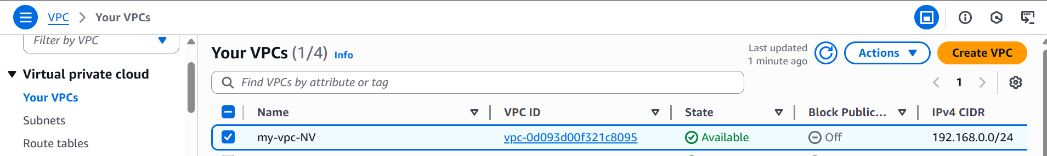

1. **Create two subnets: one public subnet and one private subnet.**

* Click on subnets
* Click on create subnets
* Create one private subnet and one public subnet

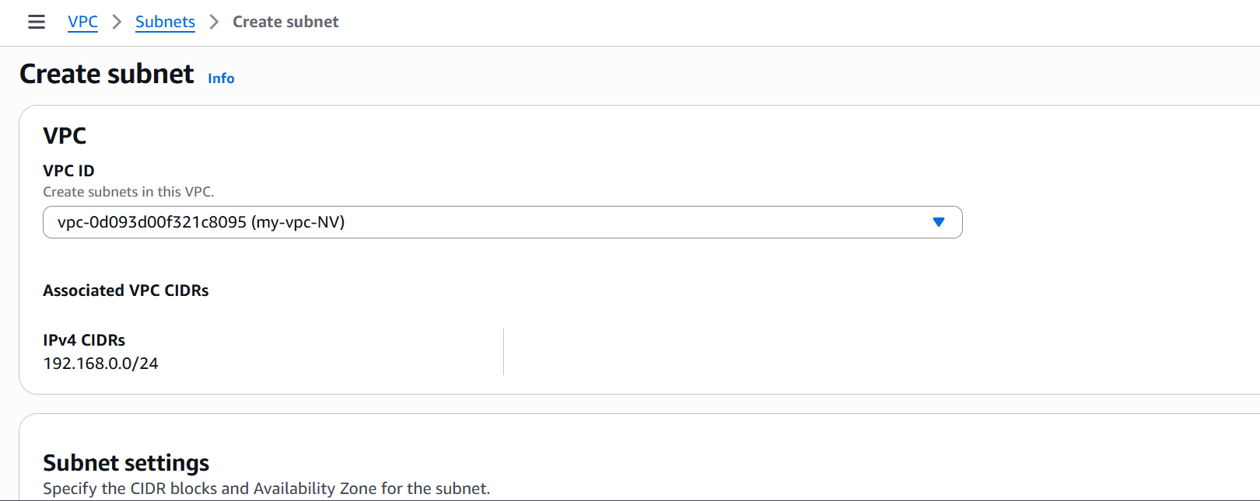

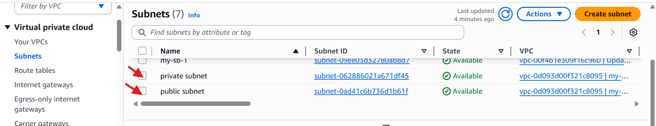

1. **Attach an IGW to the VPC.**

* Go to vpc service
* Click on internet gateway
* Click on create internet gateway

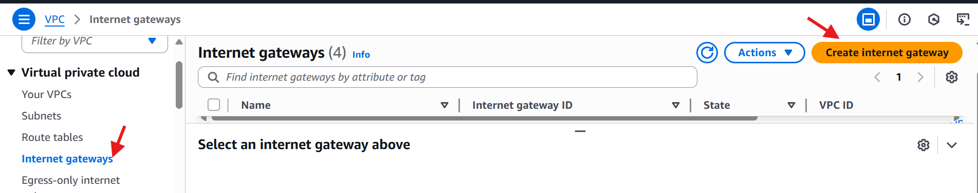

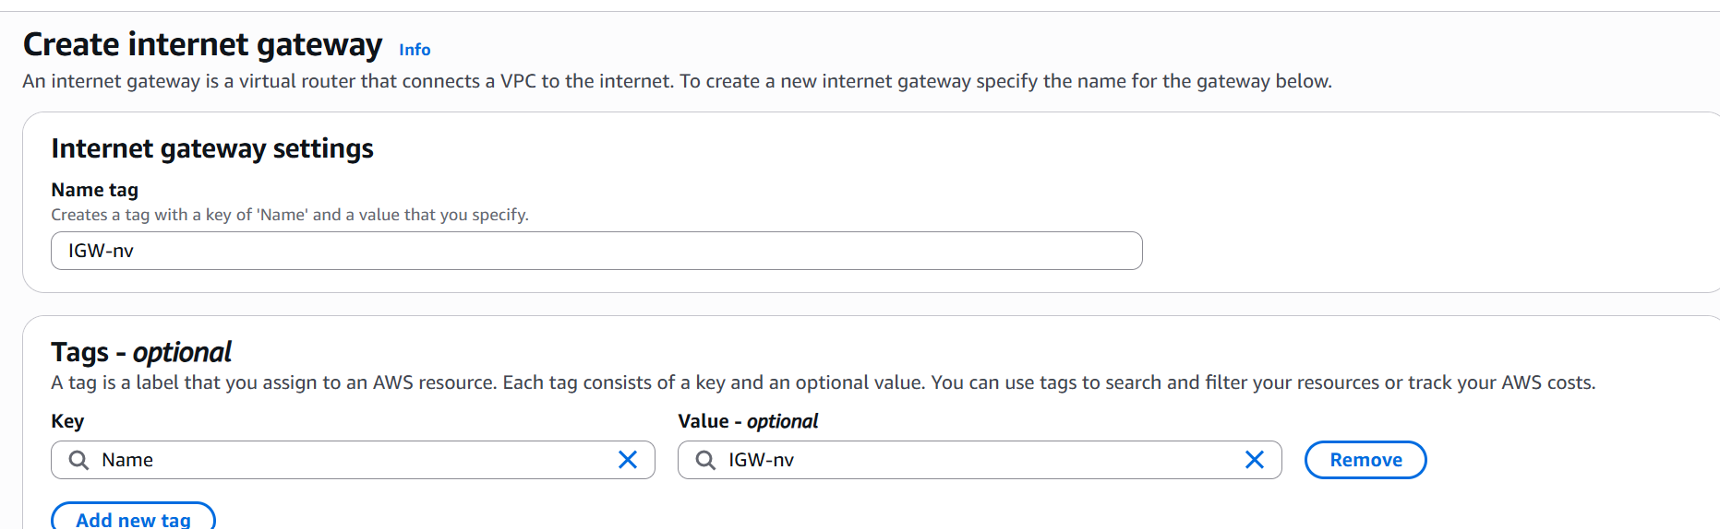

* Attach the internet gateway to vpc.

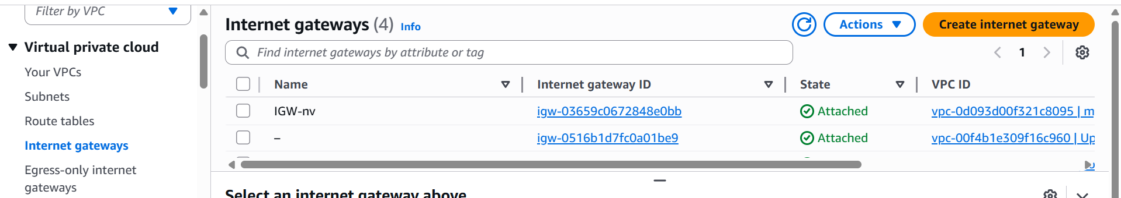

1. **Create one public route table (RT) and one private route table.**

* Go to vpc service
* Click on **route tables**.
* Click on **create route tables.**
* Create one public route table and one private route table.
* Click on **subnet associations** and attach the subnets pub-rt🡪pub-subnet , pri -rt🡪 pri-subnet.

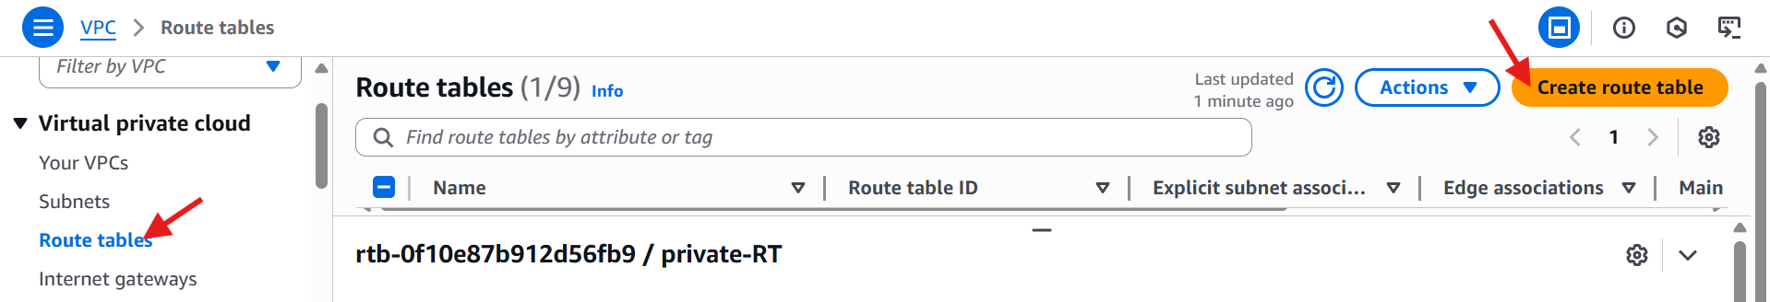

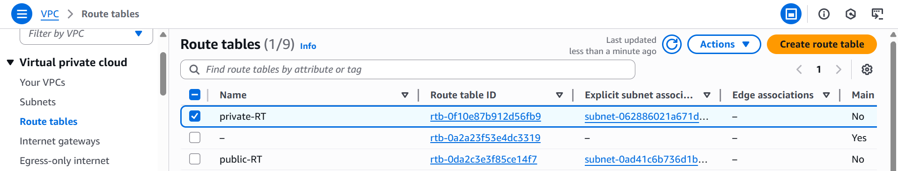

1. **Deploy a NAT gateway in the public subnet and attach the NAT gateway to the private subnet.**

* Go to **vpc service**.
* Click on **NAT gateways.**
* Click on **create NAT gateway.**

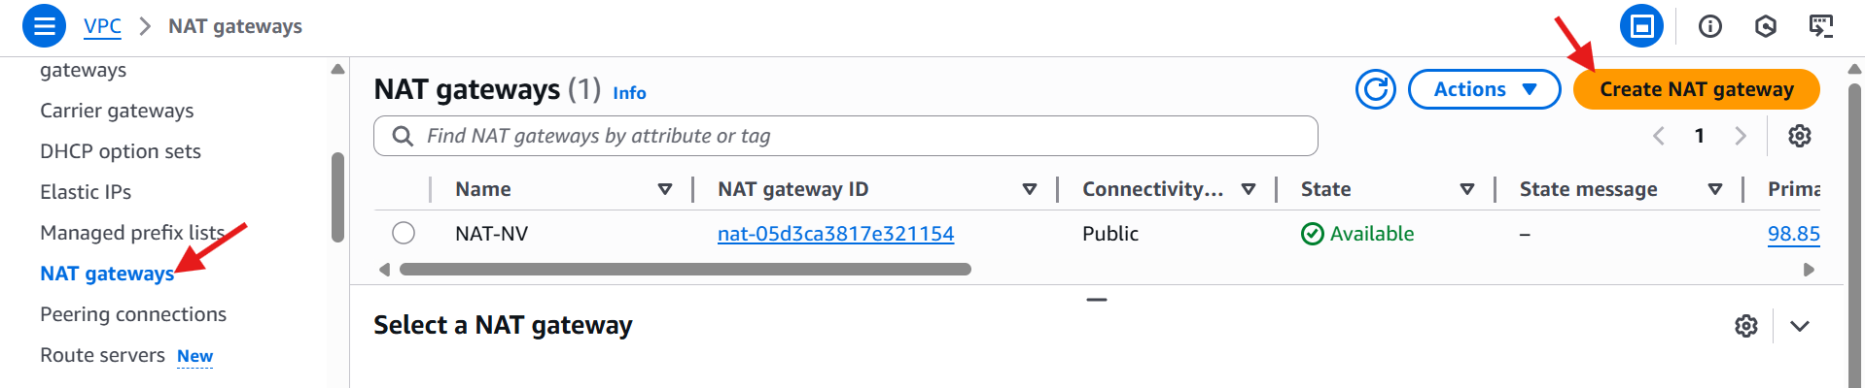

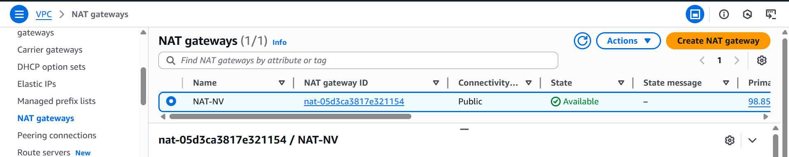

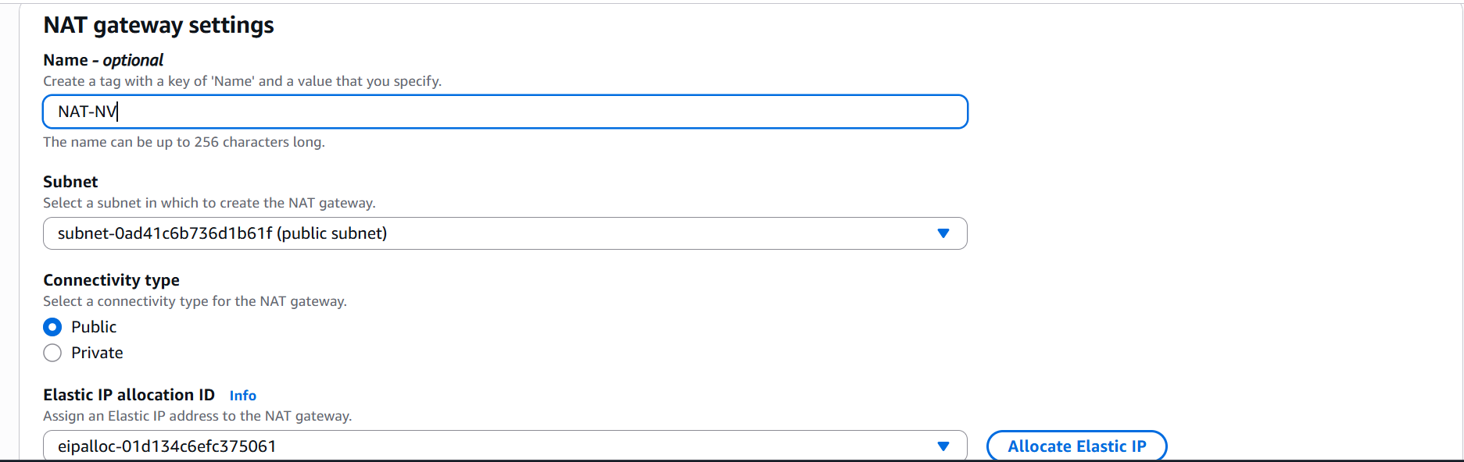

* Go to route tables and click on edit routes

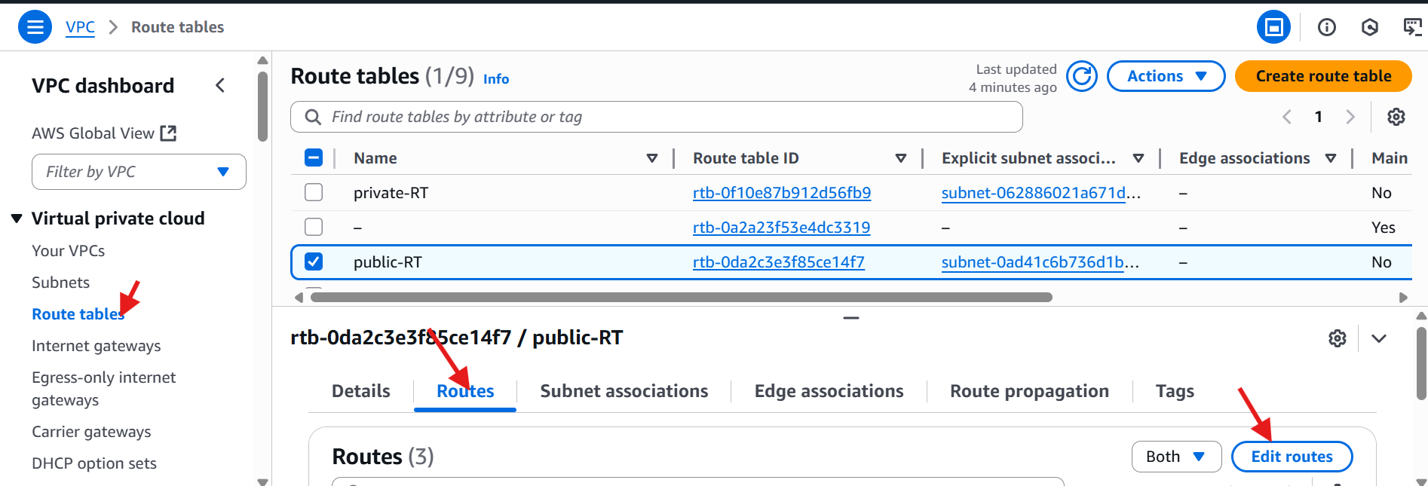

* Attach the NAT gateway to the private subnet.

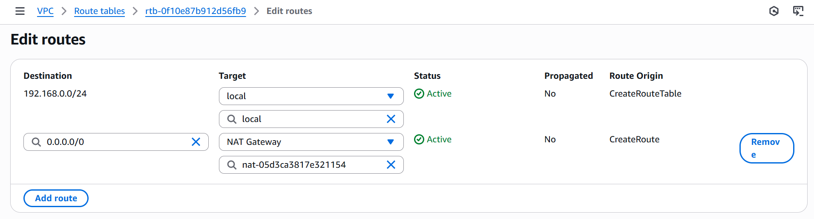

1. **Create two instances, one in the public subnet and one in the private subnet.**

* Launch two instances
* One is public and one is private.

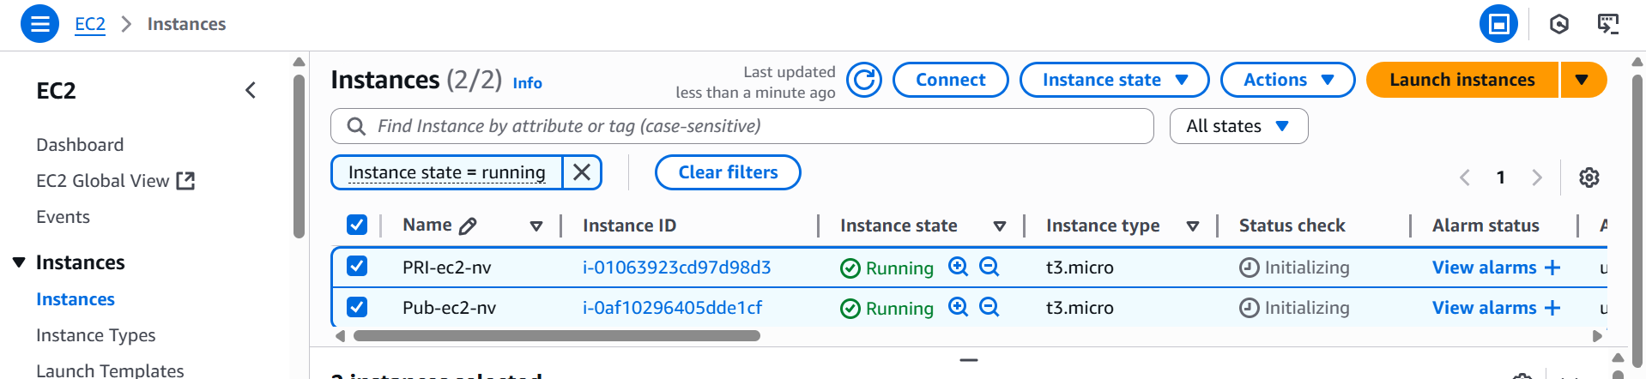

1. **Deploy Apache server on both EC2 instances with a sample index.html file.**

* Launch one public instance

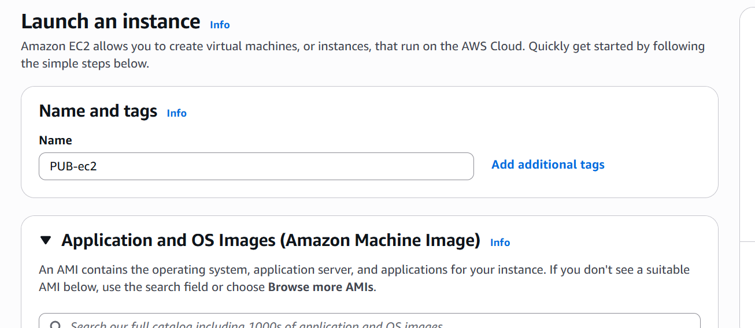

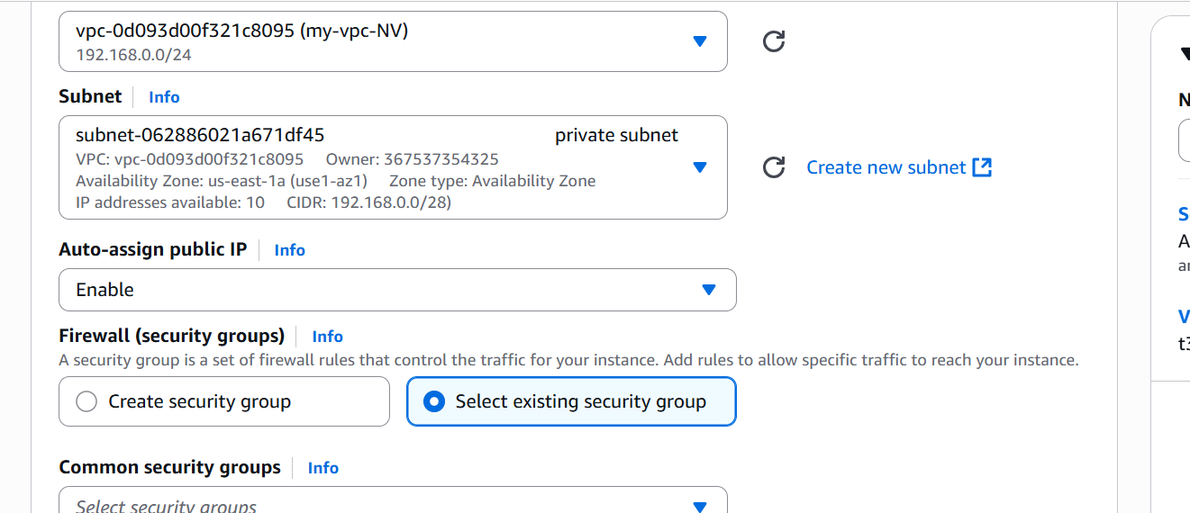

* Same for private instance



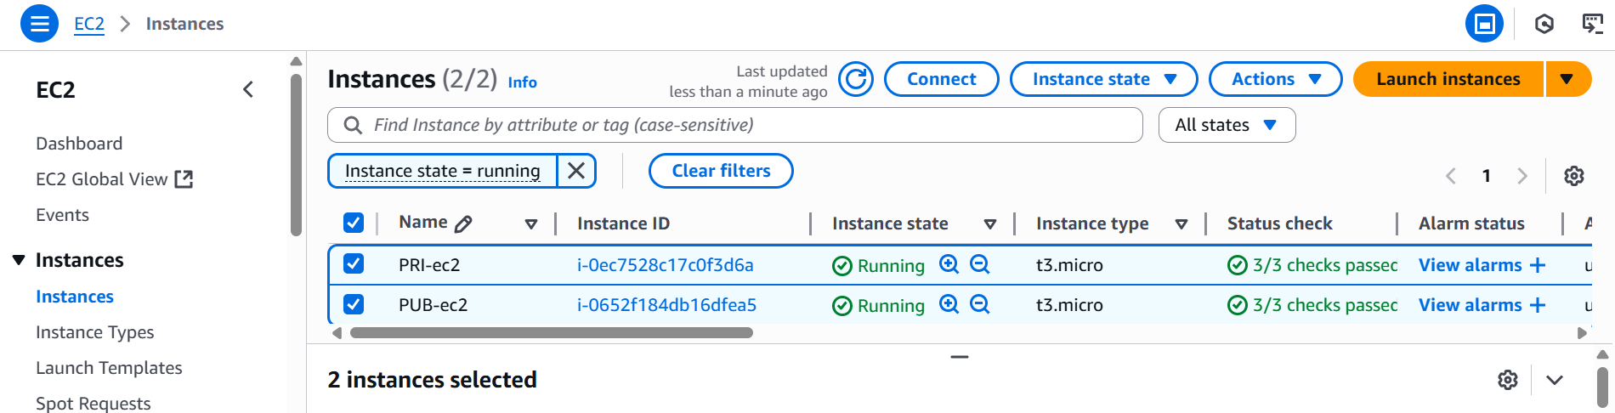

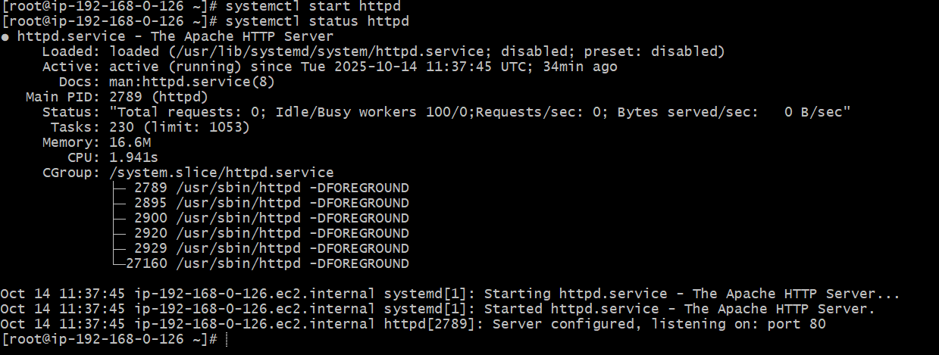



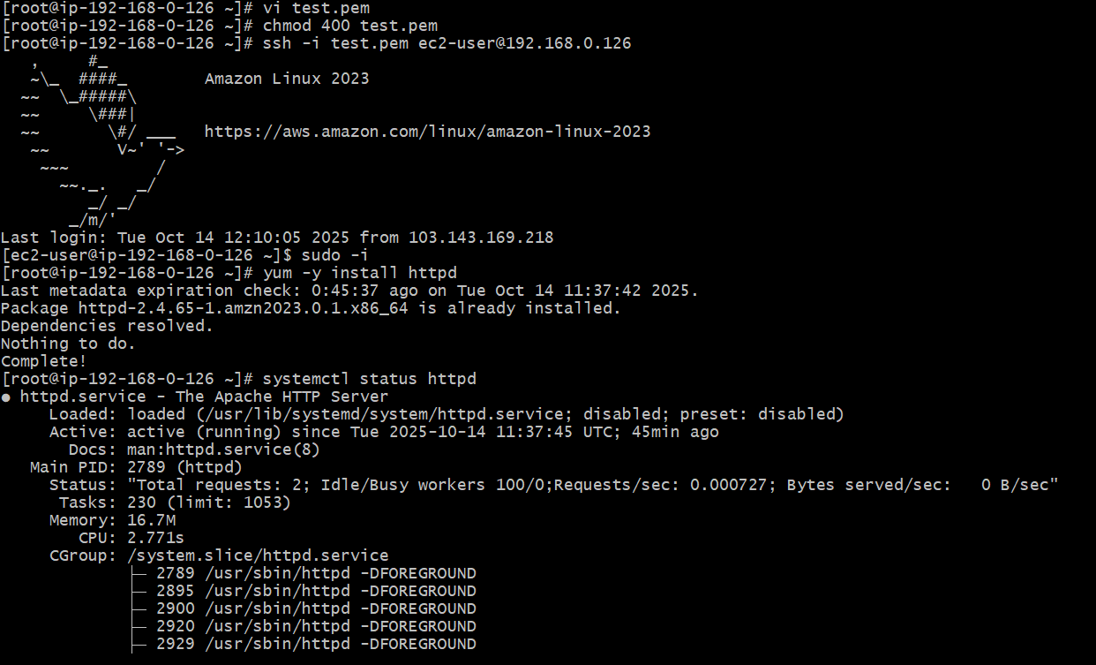



1. **Create one application load balancer and attach it to both EC2 instances.**

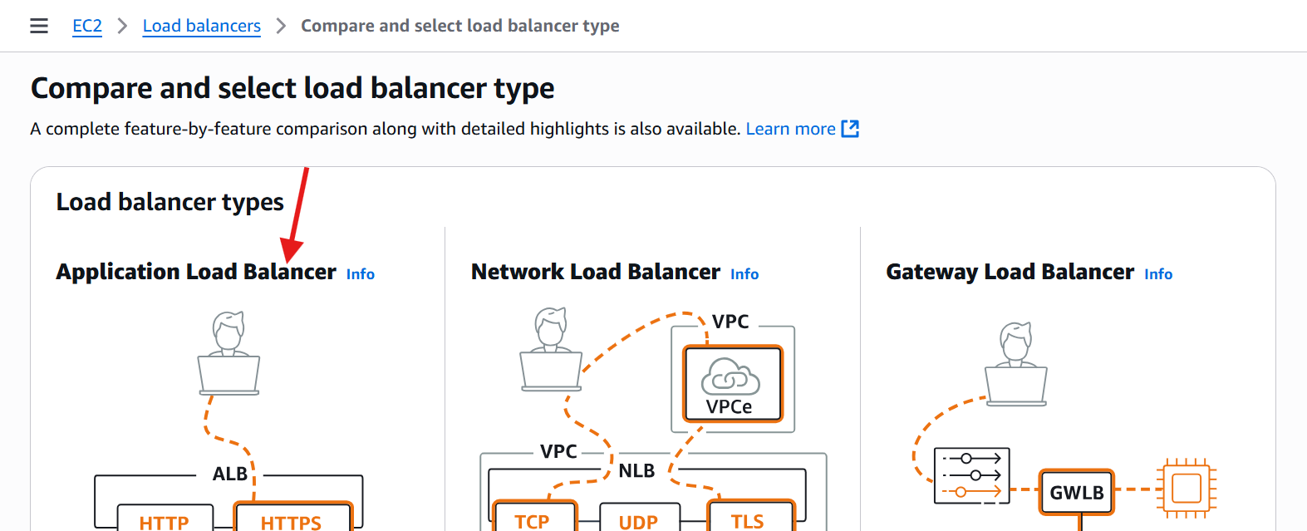

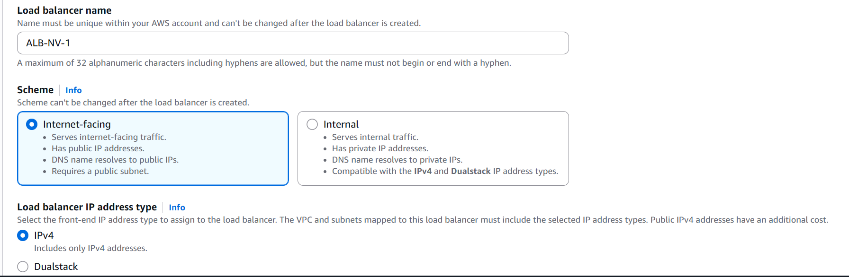

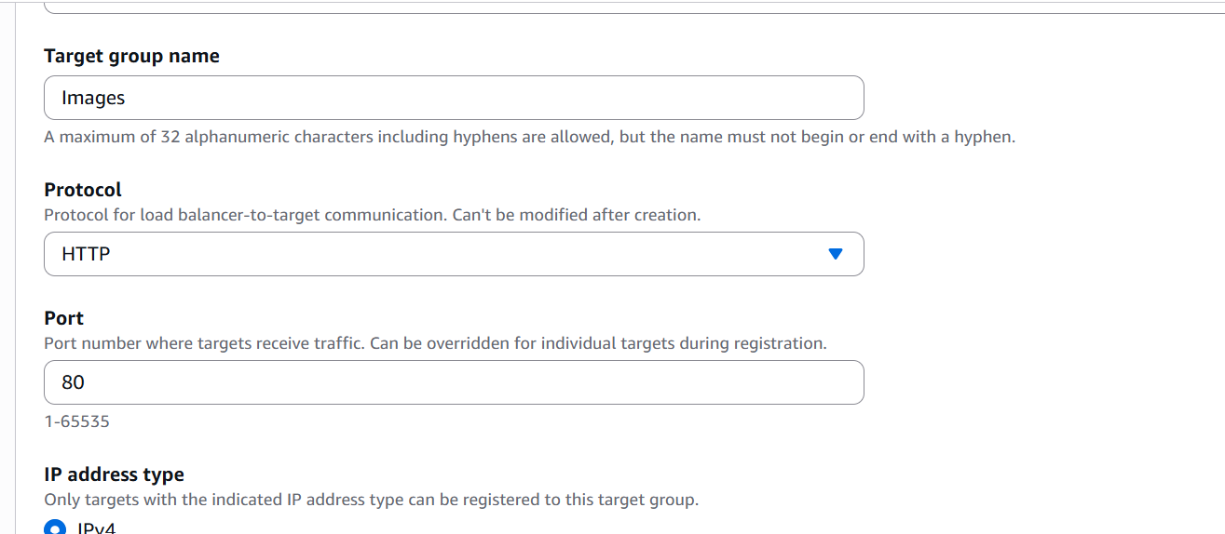

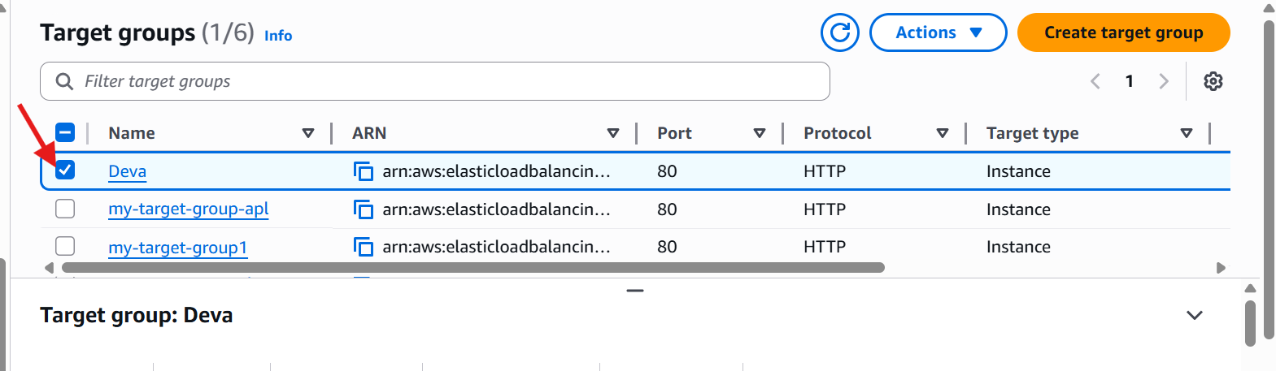

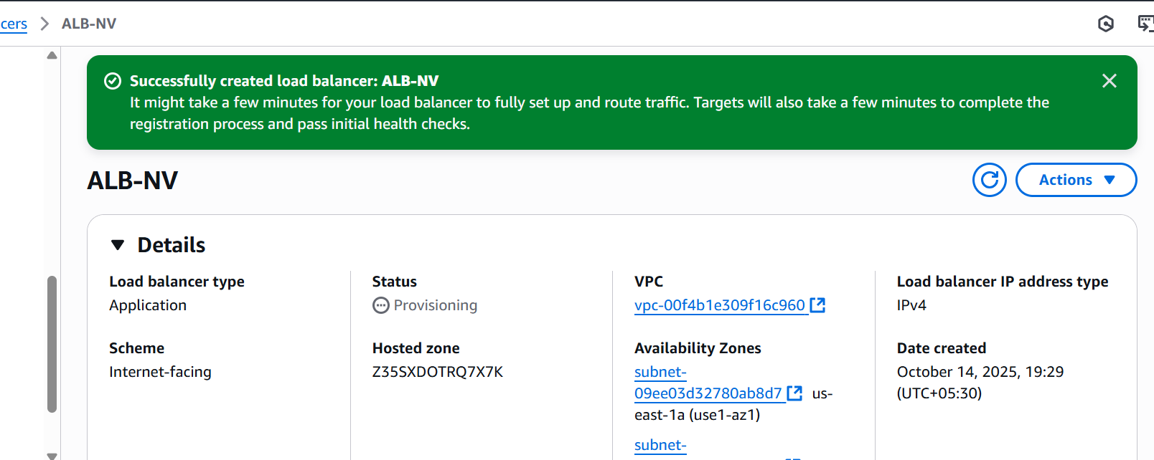

1. **Store application load balancer logs in S3.**

* Go to the AWS console.
* Then open search bar and go to the s3 bucket
* And create a s3 bucket with a unique name.

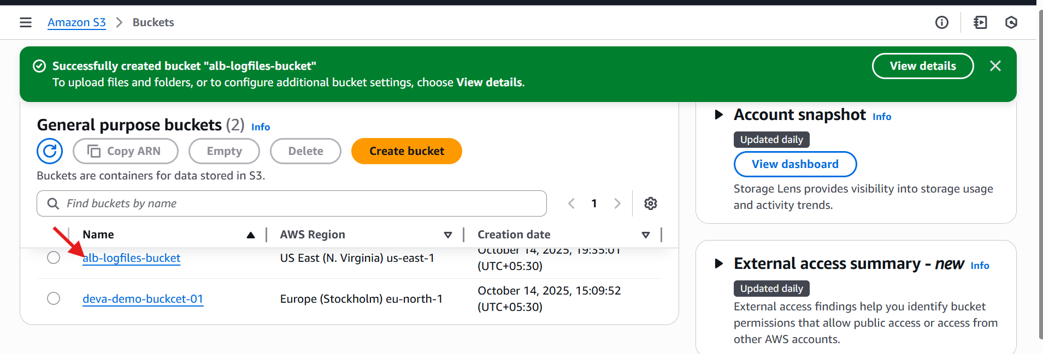

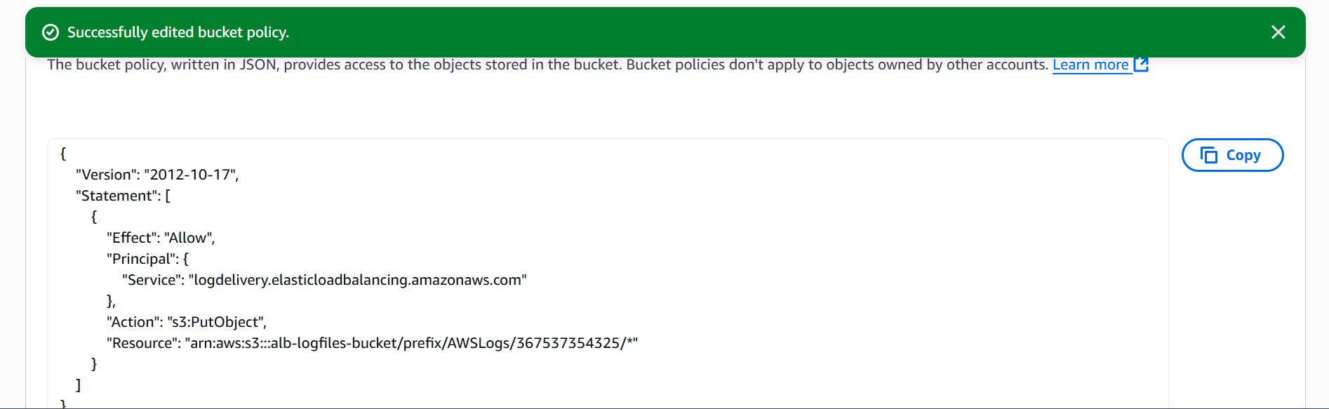

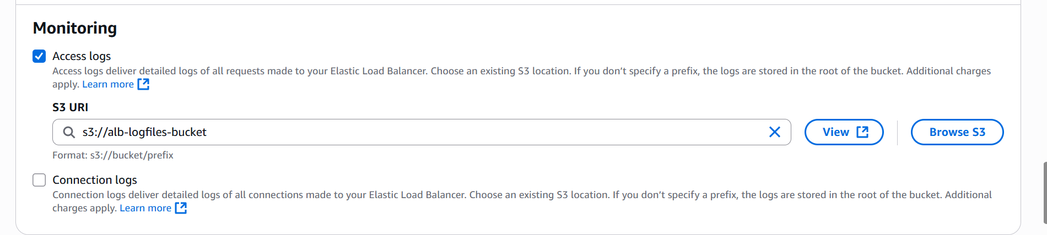

1. **Store the VPC flow logs in a Cloud Watch log group.**

* Go to **AWS management console** 🡪VPC
* In the left menu select your VPC’s
* Choose on the **flow logs**
* Click on **create flow log**
* Click on set up permission’s 🡪 crate new role it will automatically attach the policy
* Save the role

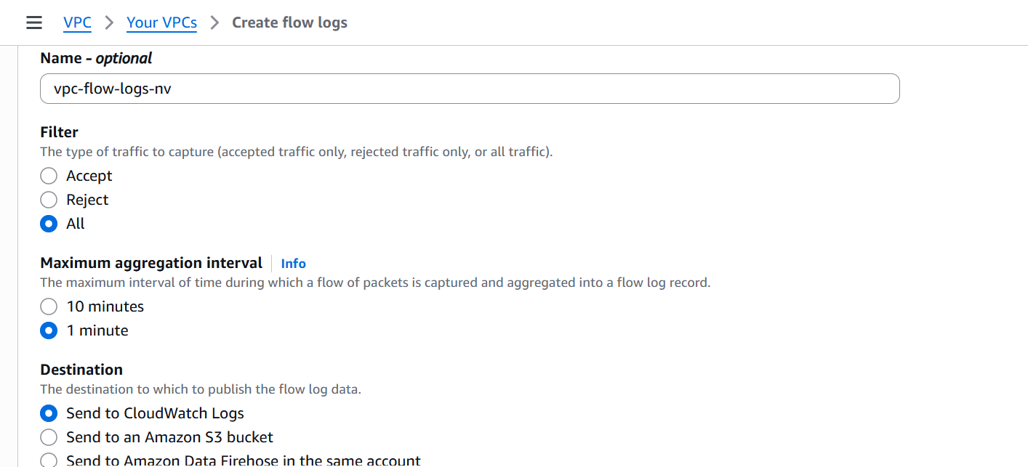

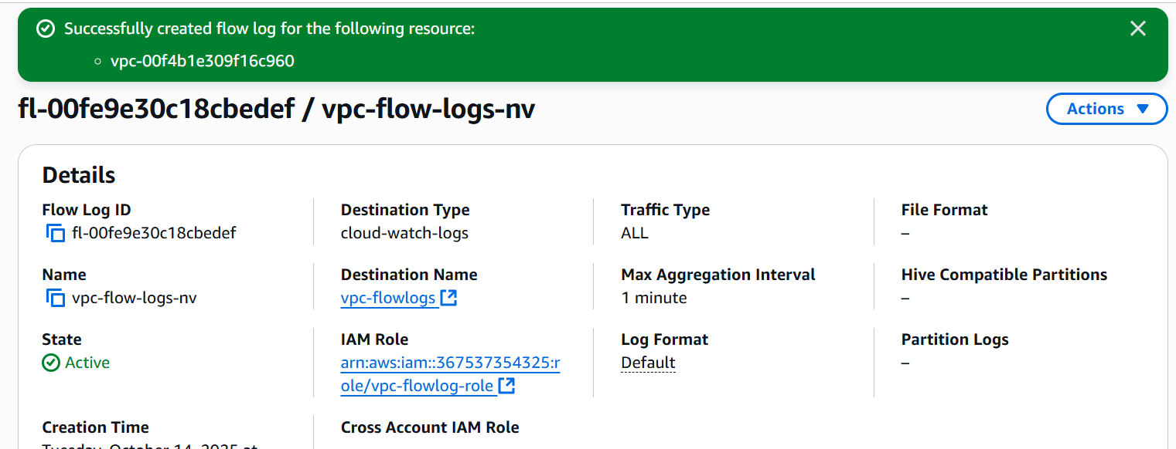

* Go to cloud watch 🡪 logs 🡪log groups
* Click on create log groups
* Name it /VPC flow logs
* Go back to VPC console select destination🡪Cloud watch logs, log group name🡪 VPC flow logs
* IAM role🡪VPC flow logs
* Go to cloud watch 🡪logs🡪 log groups🡪VPC flow logs

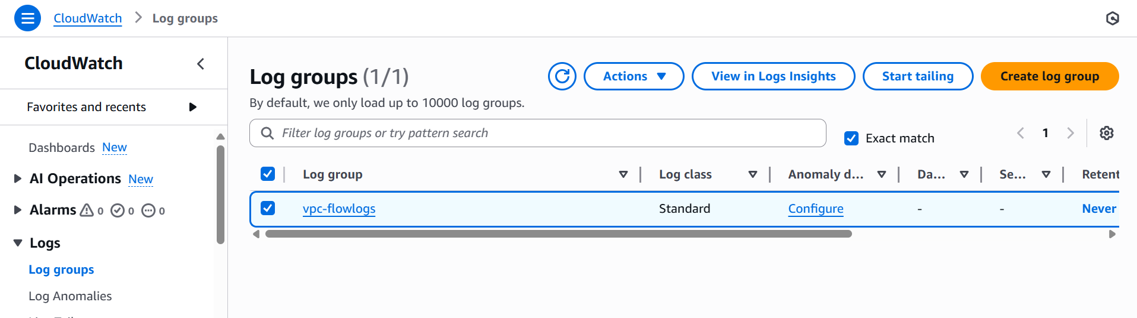

1. **Create monitoring dashboards to monitor CPU utilization and to monitor the Apache service.**

* Go to AWS console.
* Then create instance and install HTTPD.

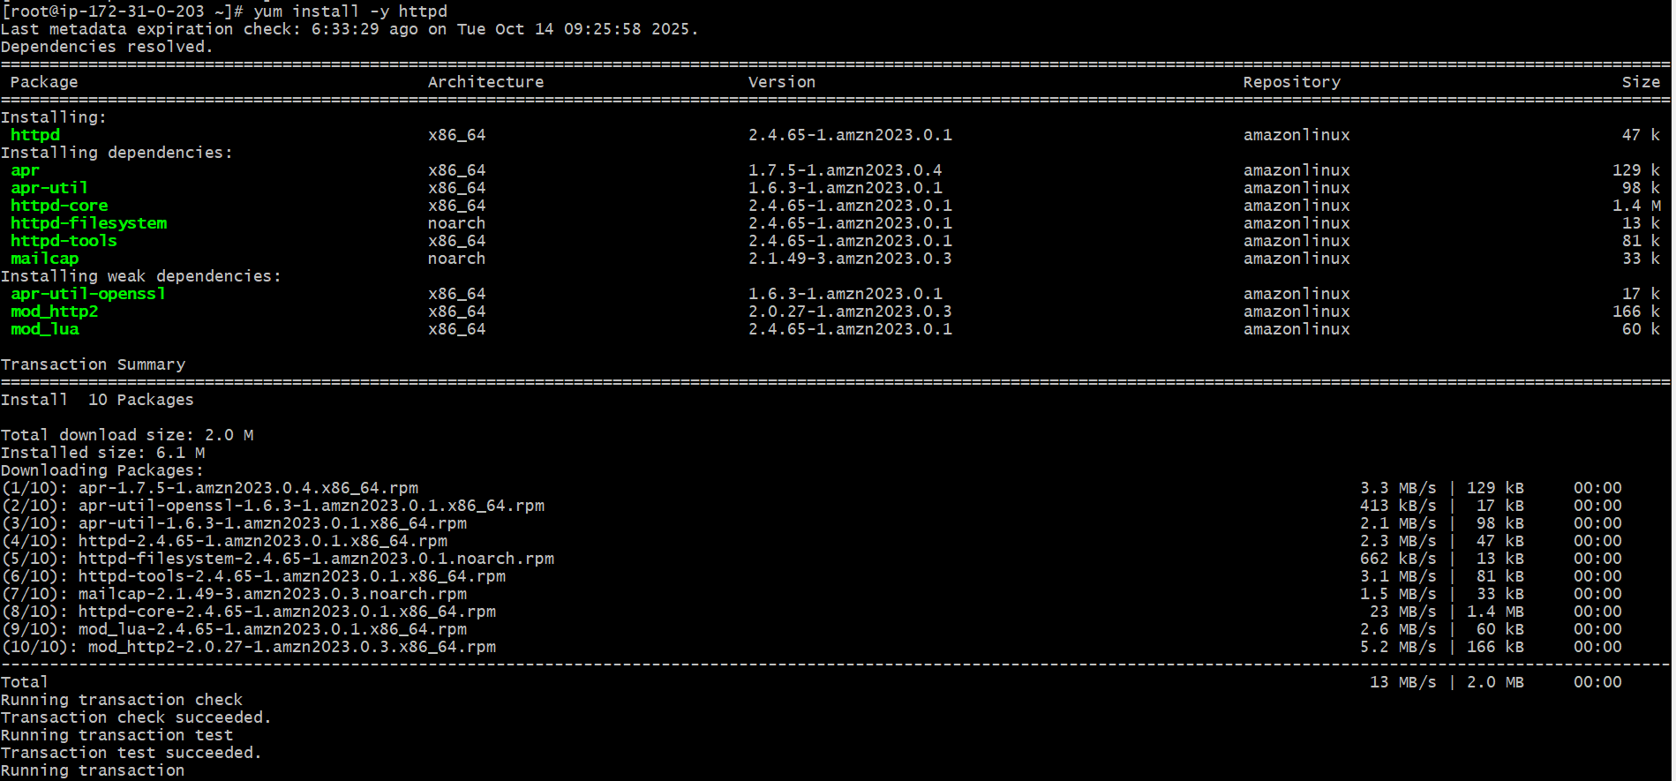

* Go to cloud watch and create a dashboard.
* With name of apache-sg.
* Then use line & number to different widget and take in to our instance.
* Then copy of instance id.
* Select the instance.
* Then here the results are

